Mod 15 JavaScript Notes

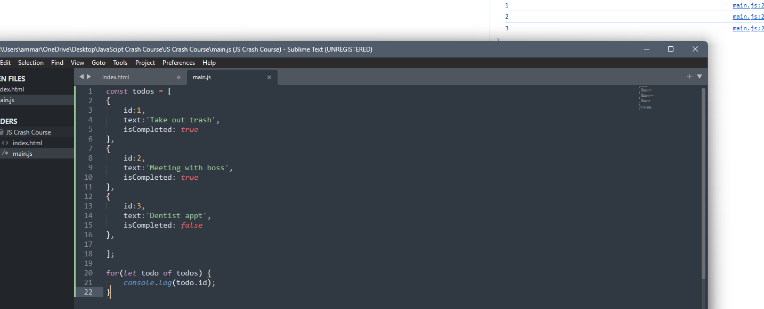

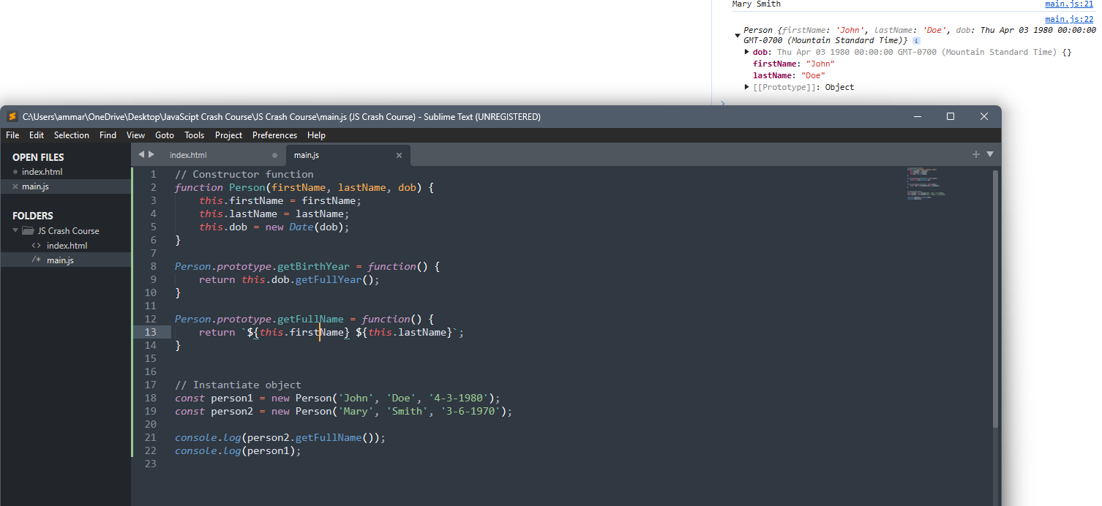

1:10:50

DOM code link in description

what is wrong with this code and how do i fix it?

const ul = document.querySelector('.items');

// ul.remove();

// ul.lastElementChild.remove();

ul.firstElementChild.textContent = 'Hello';

ul.children[1].innerText = 'Brad';

ul.lastElementChild.innerHTML = '<h1>Hello</h1>';

I am working on a website tutorial. I'm using Sublime text editor. I have an index.html file, a style.css file, and a main.js file. I'm trying to write code in the JS file. Do I need to copy/paste functions from the html file, or can I just write them directly in the .js file? Does the copy/paste actually copy over a functionality?

\*\*\*It was at this point that I realized why I didn’t get results on the previous 4-8 steps; because I had missed the part where he commented-out the class list items in the HTML file… I though that I was having trouble linking the file paths or something. I only realized this basic mistake when he went back to re-comment them out for the final process.

